Abstract— Direction-of-Arrival (DoA) estimation is a key concept for RF localization systems; however, performance is highly dependent on array geometry, environmental conditions, and algorithm development. This research presents a hybrid antenna array system designed to estimate the azimuth, elevation, and range of a moving RF source using subspace-based DoA techniques. This system combines a vertical uniform linear array (ULA) with either a circular or horizontal linear array configuration and processes received signals using the MUSIC algorithm implemented on the FMComms5/Zynq software-defined radio (SDR) platform. By separating the antenna geometry into orthogonal array structures, the system reduces the two-dimensional DoA estimation problem into two independent one-dimensional estimations for azimuth and elevation. This approach significantly reduces computational complexity and enables more efficient real-time processing. System performance was evaluated through Monte Carlo simulations as well as experimental testing with both static and moving RF sources. Results demonstrate that array geometry significantly influences estimation accuracy and snapshot requirements, while the algorithm provides stable DoA estimation under realistic indoor conditions. These findings highlight the practical advantages and limitations of hybrid antenna array configurations for real-time RF localization.
Keywords— Direction-of-Arrival (DoA), Azimuth, Elevation, Localization, Uniform Linear Array (ULA), Uniform Circular Array (UCA)

INTRODUCTION
In recent years, unmanned aerial vehicles (UAVs) have become more common in commercial, industrial, and defense settings, which has increased interest in practical ways to track and locate them. Small UAVs can be difficult to detect and localize consistently because they may fly low, change direction quickly, and transmit relatively low-power RF signals, while optical sensors like LiDAR typically require the target to be within the sensor’s field of view and can be affected by clutter or multipath. This work presents a real-time RF localization prototype capable of estimating the azimuth, elevation, and range of a single static or moving 2.4 GHz RF source. Angular estimates are obtained using multi-element antenna arrays and subspace-based DoA algorithms, while range is measured using a mechanically steered LiDAR unit. Multiple array configurations, including ULA/UCA and orthogonal ULA/ULA arrangements, are evaluated while using the MUSIC algorithm under consistent indoor test conditions. Performance is quantified using mean angular error and standard deviation across varying SNR levels and snapshot counts to determine the most accurate and stable configuration for single-source localization.

Project Objectives

The primary objective of this project is to develop a real-time radio frequency (RF) localization system capable of estimating the azimuth, elevation, and range of a single moving RF source. Angular localization (azimuth and elevation) is achieved through direction-of-arrival (DoA) estimation techniques, while range information is obtained using a LiDAR-based distance sensing system. The estimated angular coordinates are used to mechanically steer a pan-and-tilt LiDAR apparatus, enabling full localization in spherical coordinates (φ, θ, r).

To achieve angular estimation, multiple antenna array geometries are investigated, including Uniform Linear Array (ULA) and Uniform Circular Array (UCA) configurations. Hybrid array combinations consisting of ULA/UCA and orthogonal ULA/ULA arrangements are implemented to evaluate their suitability for two-dimensional DoA estimation. All of these hardware configurations will be implemented using the Multiple Signal Classification (MUSIC) algorithm. Performance is assessed under consistent indoor testing conditions using a single 2.4 GHz RF source.
Quantitative evaluation metrics include the mean angular error and standard deviation of azimuth and elevation estimates across Monte Carlo simulations and experimental trials. These metrics are used to determine the most accurate and stable array–algorithm configuration for single-source localization. The overall goal is to identify a system architecture that provides reliable, low-variance angular estimation suitable for real-time implementation.

Project Deliverables

While completing this project, several deliverables are required to demonstrate successful system development and validation. The primary deliverable is a functioning real-time RF localization system that meets the performance parameters outlined in the project proposal. The final system demonstration will display azimuth and elevation direction-of-arrival (DoA) estimates produced by the antenna array processing chain while operating on the full competition hardware stack. When integrated, the system will also incorporate LiDAR-based ranging controlled by the DoA estimation results, enabling full spatial localization of the RF emitter in the form of azimuth, elevation, and range $(ϕ,θ, r)$ within the defined test environment.

Throughout the duration of the project, progress will be documented through periodic design reports and presentations that demonstrate development milestones, testing procedures, and system integration progress. These reports provide verification that project goals are being met and allow for evaluation of both the design methodology and implementation results.

Additional deliverables include documented software and hardware support packages to ensure the reproducibility of experimental results. These materials consist of MATLAB simulation and processing scripts, antenna array CAD drawings, system configuration files, experimental datasets, and setup instructions describing required dependencies and operating procedures. A formal testing procedure will also be provided outlining the experimental configuration, calibration steps, parameter settings, and evaluation metrics used to assess system performance. Supporting documentation will be included within this report or provided as supplemental appendices for further reference.

MATHEMATICAL BACKGROUND
This section develops the mathematical background for the subspace-based direction-of-arrival (DoA) estimation techniques evaluated in this work. The analysis begins with a narrowband signal model in which an electromagnetic wave emitted from a distant RF source impinges on an antenna array. Under the far-field assumption, the incoming wavefront can be approximated as planar across the array aperture, allowing the direction of arrival to be described using azimuth (𝜙) and elevation (𝜃) angles relative to the array coordinate system. Figure 1 illustrates this geometric relationship, showing the incident RF source and the angular parameters used to describe its direction. These angles define the propagation vector that determines the relative phase shifts observed across the array elements, which in turn form the basis of the array steering vector used by subspace-based MUSIC algorithm.
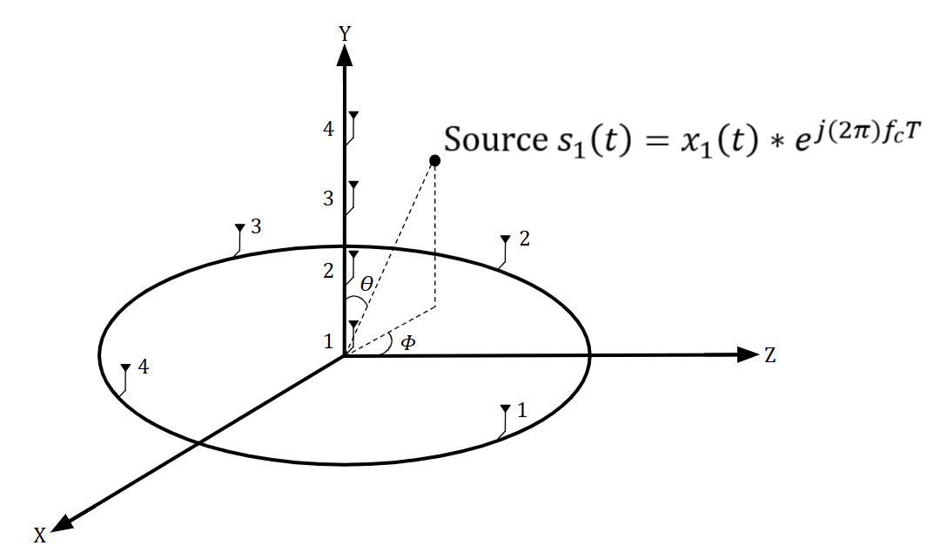
Fig 1. Direction-of-arrival split-array geometry showing the incident RF source and the azimuth (𝜙) and elevation (𝜃) angles used to construct the array steering vector.

Mathematical Signal Model

When a far-field electromagnetic wave impinges on an antenna array, the signal arrives at each element with a slightly different phase due to propagation delay. By modeling the phase difference, it becomes possible to estimate the direction from which the signal originated.
To define this relationship, consider the source transmitting the narrowband signal $s_{1}(t)$ that is received by an antenna array consisting of $M$ elements. For a uniform linear array with inter-element spacing $d$, the signal received at the $m^{th}$antenna element can be written as:
$y_{m}(t)=s_{1}(t)e^{-j2π\frac{d}{λ}msin⁡(θ)}+n_{m}(t)$ (1)

Where:
- $s_{1}(t)$ is the transmitted signal
- $n_{m}(t)$ is additive noise at the $m^{th}$ antenna element
- $d$ is the spacing between antenna elements
- $λ$ is the signal wavelength
- $θ$ is the direction of arrival
This formulation highlights that the direction of arrival is encoded in the relative phase differences between array elements. As shown in Figure 2, the incident wavefront arrives at each antenna with a progressive delay, resulting in a structured phase shift pattern that forms the basis of the array steering vector used in the MUSIC algorithm.
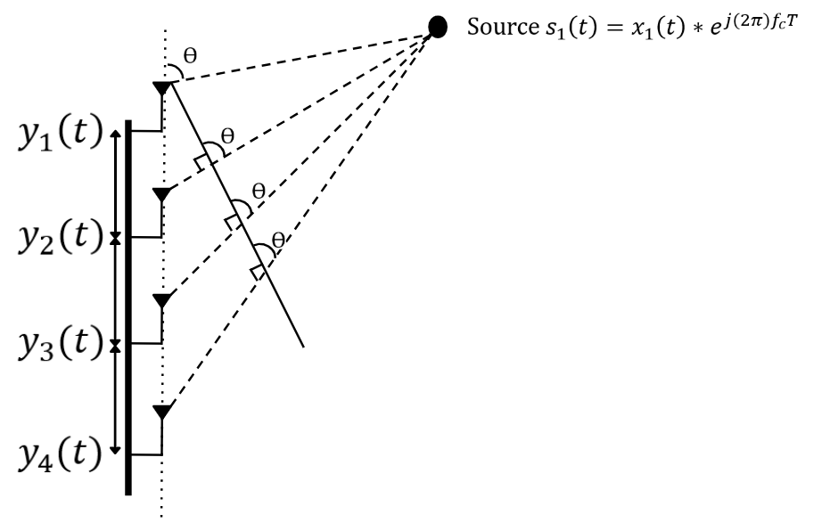
Fig 2. MUSIC DoA Model with Source impinging on ULA

The received array measurements at time 𝑡 can be expressed as a column vector whose entries correspond to the signals observed at each antenna element. Under the single-source assumption, the array output is modeled as the product of a direction-dependent steering vector and the transmitted signal, corrupted by additive noise. The received signal vector is therefore written as:

$$Recieved Values Steering Vector Noise Vector$$
$$Y\left(t\right) = A(Ө)*s_{1}(t) + N(t)$$
$$\left|\begin{matrix}y_{1}\left(t\right) \\ y_{2}\left(t\right) \\ y_{3}\left(t\right) \\ y_{4}\left(t\right)\end{matrix}\right| = \left|\begin{matrix}1 \\ e^{-jdksinӨ} \\ e^{-j2dksinӨ} \\ e^{-j3dksinӨ}\end{matrix}\right|x_{1}\left(t\right)*e^{j\left(2π\right)f_{c}T} + \left|\begin{matrix}N_{1}\left(t\right) \\ N_{2}\left(t\right) \\ N_{3}\left(t\right) \\ N_{4}\left(t\right)\end{matrix}\right|$$
Where the wave number, k, is expressed as:
$k=\frac{2π}{λ}$ (2)
After a sufficient number of samples are received, the data can be arranged into a matrix form:

$X=[x\left(1\right) x\left(2\right) … x\left(N\right)]$ (3)
In conventional subspace-based DoA algorithms, the spatial covariance matrix is formed from this snapshot matrix and utilizes eigenvalue decomposition. However, for this work, singular value decomposition (SVD) is applied directly to the snapshot matrix. The SVD of the data matrix is given by:
$X=UΣV^{H}$ (4)

Where $U∈C^{M×M}$ contains the left singular vectors, $Σ$ is a diagonal matrix of singular values, and $V^{H}$ contains the right singular vectors. For the single-source case considered in this system, the dominant singular value corresponds to the signal subspace, while the remaining singular values correspond to noise. Accordingly, the matrix $U$ can be partitioned as

$U=[\begin{matrix}U_{S} & U_{N}\end{matrix}]$ (5)

The MUSIC algorithm exploits the orthogonality between the noise subspace and the true steering vector. For the correct direction of arrival, the steering vector lies entirely within the signal subspace and is therefore orthogonal to the noise subspace:
${U_{N}}^{H}*a\left(θ\right) ≈0$ (6)

Using this property the DoA estimate is obtained by searching over 𝜃 and selecting the angle corresponding to the maximum value:
$P_{MUSIC}\left(θ\right)=\frac{1}{a^{H}\left(θ\right)U_{N}{U_{N}}^{H}a\left(θ\right)}$ (7)

Within real-time applications, the standard MUSIC algorithm can suffer from reduced performance in multipath or heavily cluttered environments where correlated signal reflections may be present. To mitigate this effect, forward–backward averaging was applied to the received data matrix to improve the stability of the subspace estimation. This technique effectively increases the usable snapshot information by incorporating both the forward and reversed sensor data, which helps decorrelate multipath components and improves separation between the signal and noise subspaces. The forward–backward averaged matrix is computed as:

$X_{fb}=\frac{1}{2}(X_{zz}+JX_{zz}^{*}J)$ (8)

Where $X_{zz}$is the sample data matrix, $X_{zz}^{*}$denotes the complex conjugate, and $J$ is the exchange matrix that reverses the sensor order. By combining the original data matrix with its reversed conjugate counterpart, the resulting matrix becomes more symmetric and better conditioned for the singular value decomposition used by the MUSIC algorithm.

For the Uniform Circular Array (UCA), the MUSIC algorithm itself remains unchanged; however, the steering vector must be modified to reflect the circular array geometry. Unlike the ULA, where phase shifts progress linearly along the array axis, each UCA element is positioned at a different angular location around a circle of radius $R$. As a result, the phase observed at each element depends on the projection of the incoming wave onto that element’s position along the circular perimeter. This relationship is illustrated in Fig. 3, where a narrowband RF source impinges on the circular array and produces different phase responses at each antenna element depending on the azimuth angle of arrival.
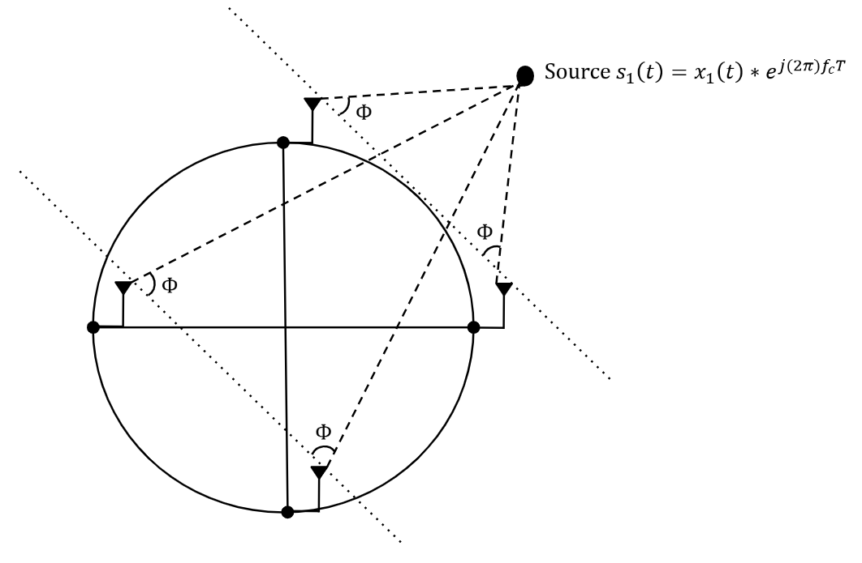
Fig 3. MUSIC DoA Model with Source impinging on UCA

Because each antenna element in the circular array occupies a unique angular position, the array response must account for the relative phase delay between the incoming signal direction and the position of each sensor element. This relationship is captured by the steering vector for the uniform circular array, which models the phase response of each antenna element as a function of the source azimuth angle:

$b\left(ϕ\right)={\left[e^{jλ2πR​cos\left(ϕ-γ1​\right)}​⋯​e^{jλ2πR​cos\left(ϕ-γM​\right)}​\right]}^{T}$ (9)

where $R$ represents the radius of the circular array, $λ$ is the signal forms the basis for subspace-based DoA estimation algorithms:

$Y\left(t\right)=b(ϕ){*s}_{1}​(t)+N_{Y}​(t)$ (10)

The MUSIC algorithm estimates the direction of arrival by evaluating a pseudospectrum obtained from the singular value decomposition of the data matrix:

$P_{MUSIC}\left(ϕ\right)=\frac{1}{a^{H}\left(ϕ\right)U_{N}{U_{N}}^{H}a\left(ϕ\right)}$ (11)
The UCA is primarily sensitive to azimuth ($ϕ$) because all elements lie in a horizontal plane, meaning there is minimal phase variation with respect to elevation. As a result, elevation information cannot be uniquely resolved using the UCA alone. To address this, the elevation angle ($θ$) is first estimated using the vertical ULA, which provides phase variation along the vertical axis. This estimated elevation is then assumed when forming the UCA steering vector, allowing the system to isolate and accurately estimate azimuth.

SIMULATIONS
This section evaluates the practical performance of the proposed MUSIC algorithm through a series of targeted simulations, including SNR-based Monte Carlo simulations, snapshot-dependent Monte Carlo simulations, and full DoA estimation scenarios. These simulations are designed to assess the accuracy and robustness of the algorithm under varying conditions. By systematically varying key system parameters, the strengths and limitations of the proposed approach are revealed, providing a comprehensive evaluation of its effectiveness for real-time RF localization.

SNR vs. DoA Accuracy Monte Carlo Trails
The first parameter investigated is the signal-to-noise ratio (SNR), a major factor in subspace-based DoA estimation. In practical environments, the system must operate under noisy and multipath conditions, making SNR analysis essential for evaluating robustness.
In this simulation, the SNR varies from -10 to 10 dB using the hybrid ULA/UCA configuration, and performance is quantified using RMSE, bias, and standard deviation for both azimuth and elevation estimates. As shown in Figure 4, RMSE decreases with increasing SNR, with elevation estimation exhibiting greater sensitivity to noise than azimuth. These results demonstrate that the proposed MUSIC-based system maintains reliable performance in low SNR conditions while achieving higher accuracy as signal quality improves.

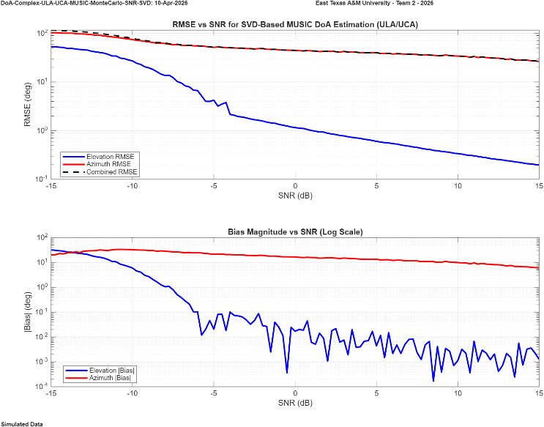
Fig 4. MUSIC ULA/UCA DoA SNR vs. Accuracy Simulation (Log Scale)
SNR: -15:15dB; Snapshots: 32, 768; Freq: 2.4GHz, Trials: 250; Single Moving Source; Azimuth: 40ᵒ:80ᵒ; Elevation: 20ᵒ:60ᵒ

Figure 5 presents the same analysis for the ULA/ULA configuration. Similar trends are observed, with decreasing RMSE, bias, and standard deviation as SNR increases. However, this configuration exhibits more balanced performance between azimuth and elevation estimation, with both achieving improved accuracy at higher SNR levels. Notably, the RMSE drops below 10° in high SNR conditions, indicating stable and consistent estimation performance.

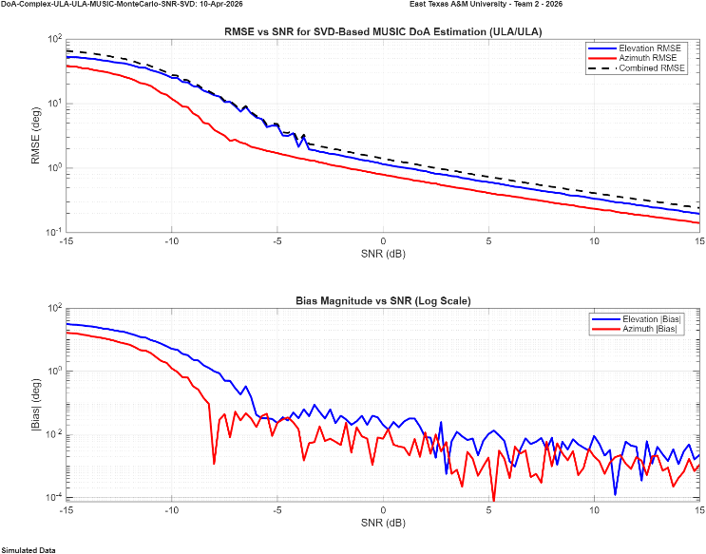
Fig 5. MUSIC ULA/ULA DoA SNR vs. Accuracy Simulation (Log Scale)
SNR: -15:15dB; Snapshots: 32, 768; Freq: 2.4GHz, Trials: 250; Single Moving Source; Azimuth: 40ᵒ:80ᵒ; Elevation: 20ᵒ:60ᵒ

Number of Snapshots vs. Accuracy Monte Carlo Trails
The second set of Monte Carlo simulations evaluates the performance of the MUSIC algorithm under a limited number of snapshots. This is a critical factor for real-time systems, as increasing the number of snapshots generally improves estimation accuracy but also increases computational time, reducing real-time capability. The objective of this analysis is to identify a snapshot count that balances estimation accuracy and computational efficiency. By varying the number of snapshots, the impact on RMSE, bias, and estimation stability can be observed, providing insight into the minimum data requirements for reliable DoA estimation.
In Figure 6, the RMSE is evaluated for a static source over a snapshot range from 512 to 32,768, which represents the maximum supported by the hardware. The simulation is conducted at an SNR of −10 dB, representing a realistic operating condition for the system in a typical environment. As the number of snapshots increases, the RMSE decreases, and the MUSIC spectrum exhibits more well-defined peaks, indicating improved estimation reliability.

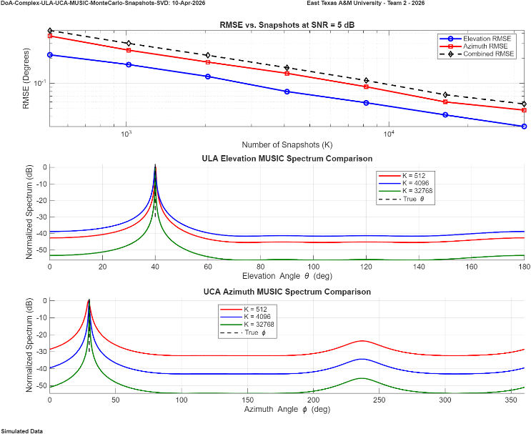
Fig 6. MUSIC ULA/UCA DoA Snapshots vs. Accuracy Simulation (Log Scale) SNR: 5dB; Snapshots: 512: 32,768; Freq: 2.4GHz, Trials: 250; Single Static Source; Azimuth: 30ᵒ; Elevation: 40ᵒ

Similarly, Figure 7 demonstrates the same inverse relationship between RMSE and the number of snapshots. However, in the dual ULA configuration, the RMSE decreases at a faster rate compared to the ULA/UCA configuration, suggesting improved convergence behavior and estimation efficiency under limited data conditions.

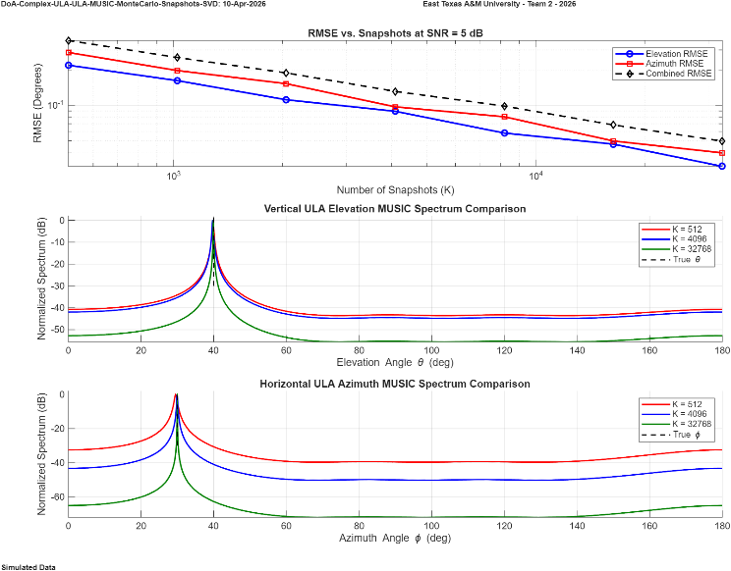
Fig 7. MUSIC ULA/ULA DoA Snapshots vs. Accuracy Simulation (Log Scale) SNR: 5dB; Snapshots: 512: 32,768; Freq: 2.4GHz, Trials: 250; Single Static Source; Azimuth: 30ᵒ; Elevation: 40ᵒ

Simulated DoA Estimation
The final set of simulations evaluates system performance under a more realistic scenario involving a single moving RF source. This test measures the ability of the system to continuously track azimuth and elevation as the source follows a defined trajectory. At each step, the estimated angles are compared to the true values to compute instantaneous error, and a running RMSE is calculated to quantify cumulative performance over time. This provides insight into tracking stability, convergence behavior, and overall system accuracy during dynamic operation.
As shown in Fig. 8, the ULA/UCA configuration demonstrates accurate tracking performance. The estimated trajectory closely follows the true path across the full azimuth and elevation range. The error plot, shown on a logarithmic scale, includes the running RMSE, which converges and stabilizes despite some initial variability in the instantaneous error. The final RMSE values of approximately 0.913° in azimuth and 0.687° in elevation indicate strong overall performance for the hybrid ULA/UCA system.

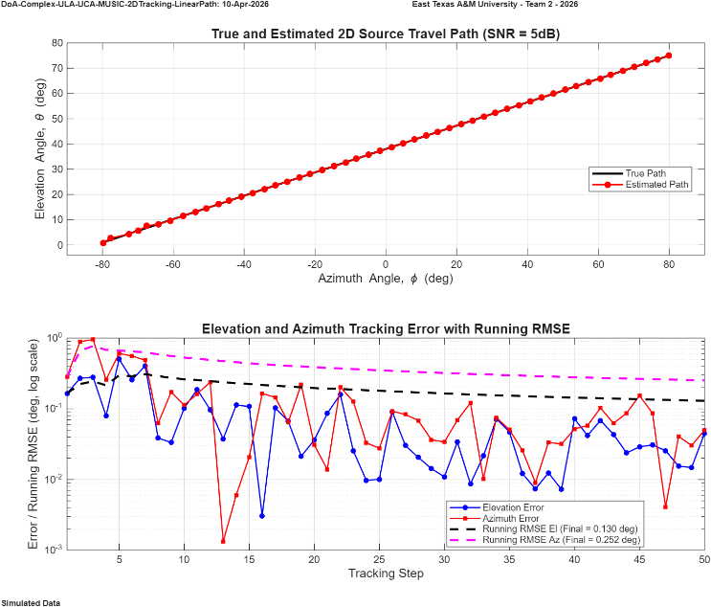
Fig 8. 2D DoA MUSIC Tracking of Single Moving Source ULA/UCA (Log Scale); SNR: 5dB; Snapshots: 10,000; Frequency: 2.4 GHz; Azimuth Range: −80°:80°; Running RMSE=0.252°;
Elevation Range: 1°:75°; Running RMSE=0.130°

Figure 9 presents the corresponding moving source tracking results for the ULA/ULA configuration. The estimated trajectory closely follows the true path across both the azimuth and elevation dimensions throughout the full sweep range. The running RMSE converges rapidly and remains stable, with final values of approximately 0.136° in azimuth and 0.701° in elevation. Notably, the ULA/ULA configuration achieves a substantially lower azimuth RMSE compared to the ULA/UCA system, suggesting that the orthogonal linear array geometry provides improved angular resolution in the azimuth plane under these simulated conditions.

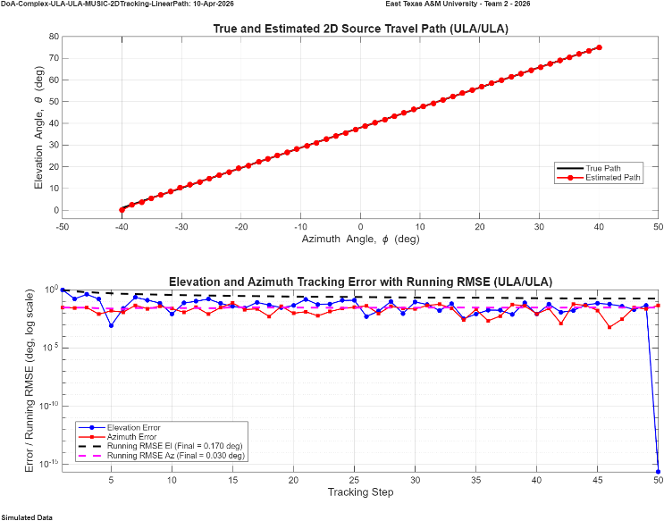
Fig 9. 2D DoA MUSIC Tracking of Single Moving Source ULA/ULA (Log Scale); SNR: 5dB; Snapshots: 10,000; Frequency: 2.4 GHz; Azimuth Range: −80°:80°; Running RMSE=0.170°;
Elevation Range: 1°:75°; Running RMSE=0.030°

Although these results demonstrate strong performance, they are obtained under ideal simulated conditions. In practice, factors such as noise, multipath, and hardware imperfections are expected to increase error and reduce overall accuracy.

ANTENNA RADIATION PATTERN
One important aspect of evaluating the performance of the antenna array configurations is visualizing their radiation patterns. The radiation pattern describes the spatial sensitivity of the array and provides insight into how incoming signals are received from different directions. In this work, the MATLAB Antenna Toolbox is used to simulate and visualize the radiation characteristics of the array configurations.

UCA Pattern

The first radiation pattern examined is the uniform circular array (UCA). Although this array is primarily used for direction-of-arrival estimation in the azimuth plane, it is still important to evaluate the radiation characteristics in both azimuth and elevation. The overall radiation response determines the sensitivity of the array to signals arriving from different spatial directions. For example, if an RF source arrives from a direction corresponding to a radiation null in elevation, the received signal strength at the array may be significantly reduced, causing the signal to be dominated by noise and degrading the accuracy of the DoA estimation. As shown in Fig. 10, the UCA produces a broadside radiation pattern with a broad main lobe in elevation and four prominent azimuth nulls at 0°, 90°, 180°, and 270°.

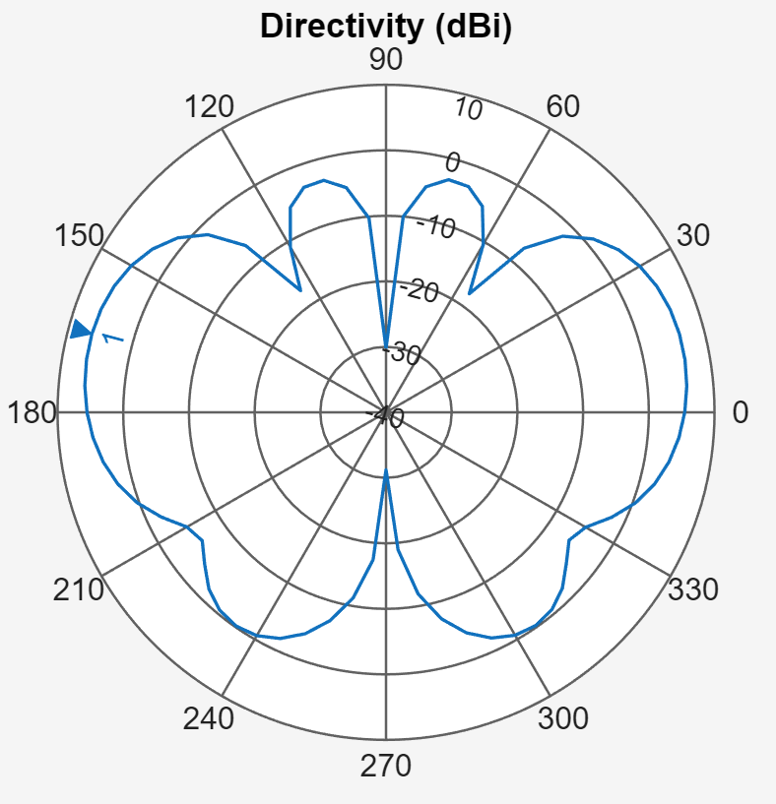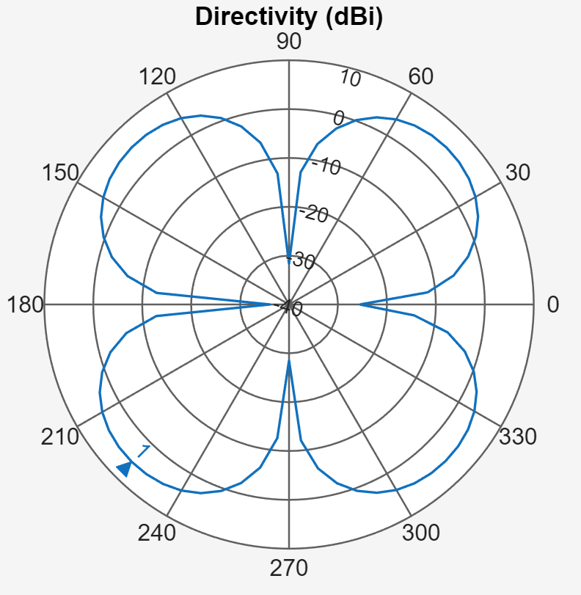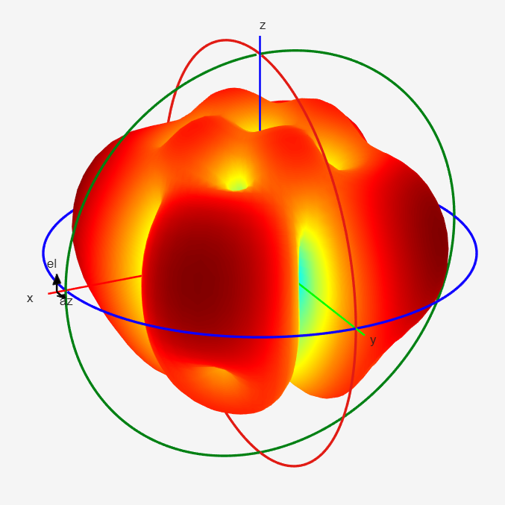
Fig 10. UCA Radiation Simulations with Elevation Plane (Left), Azimuth Plane (Right) & 3D Radiation

ULA Pattern

The second radiation pattern examined is the uniform linear array (ULA). Unlike the circular array, the ULA geometry produces a directional response primarily along the axis perpendicular to the array elements. As shown in Fig. 11, the radiation pattern is directly influenced by the spacing and phase relationships between the antenna elements, producing a dominant main lobe along with several sidelobes and nulls. This array geometry exhibits strong broadside sensitivity but reduced response along the endfire directions of the array.

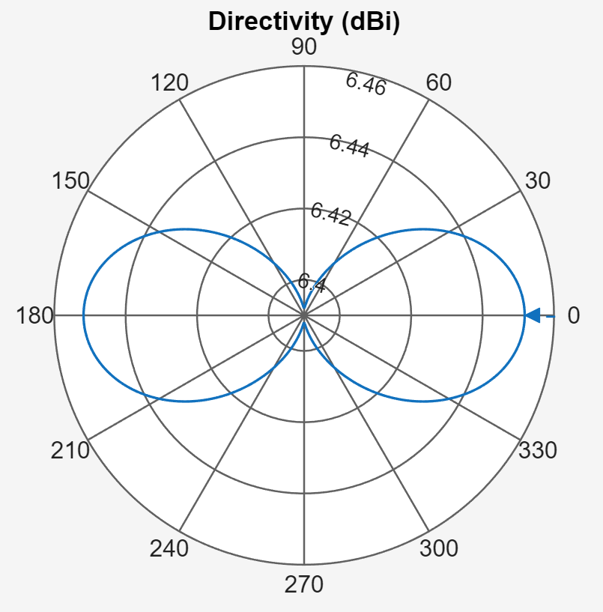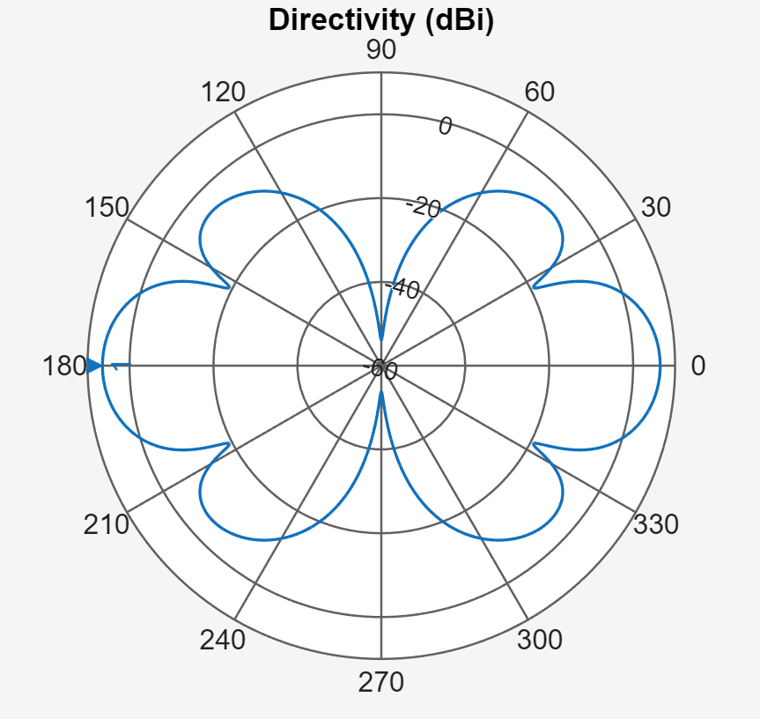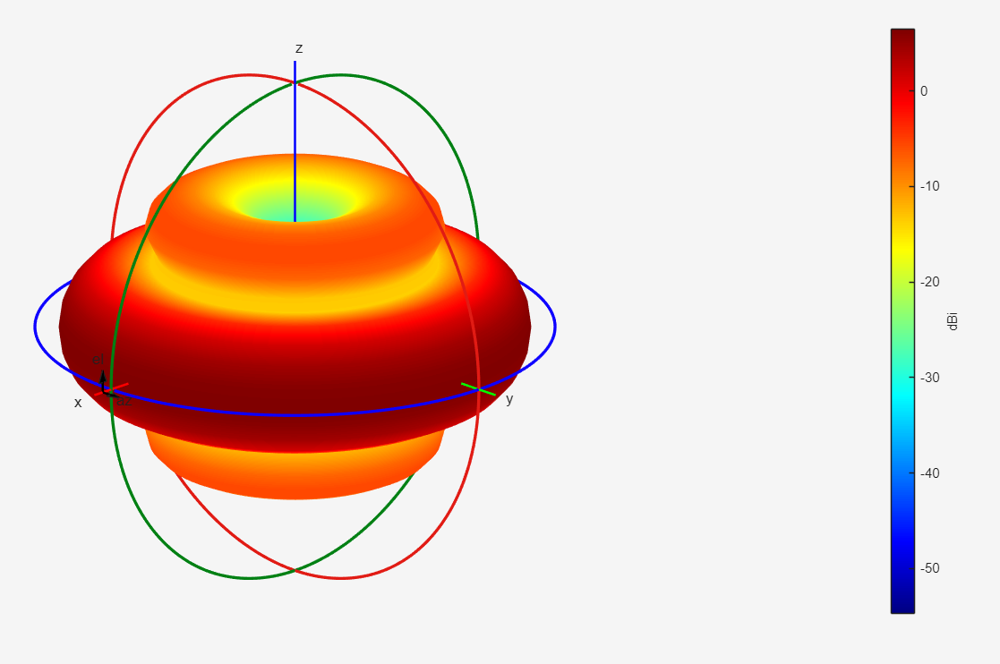
Fig 11. ULA Radiation Simulations with Elevation Plane (Left), Azimuth Plane (Right) & 3D Radiation

When the antenna elements are arranged in the ULA/UCA configuration, the resulting spatial response provides complementary directional characteristics in both azimuth and elevation. The circular array maintains a nearly uniform azimuth sensitivity, while the linear array introduces directional selectivity along the perpendicular axis. In contrast, the ULA/ULA configuration produces directional responses in both axes, resulting in stronger spatial selectivity but also introducing additional lobes and nulls in the combined radiation pattern. These characteristics highlight how the chosen array geometry influences the spatial coverage and potential blind directions of the system.

LIVE DEMO TESTING SET-UP
Our live demonstration platform is a fully operational Direction-of-Arrival (DoA) estimation system designed for real-time azimuth, elevation, and range tracking of an RF source. The physical setup consists of two orthogonally mounted four-element antenna arrays that enable independent angle estimation in both spatial dimensions. The azimuth array may be configured as either a Uniform Linear Array (ULA) or Uniform Circular Array (UCA), while the elevation array is implemented as a vertical ULA. Each array is connected to its own phase-synchronized FMComms5 + Zynq software-defined radio (SDR) platform, ensuring coherent multi-channel acquisition across all eight receive elements. The block diagram shown in Fig. 12 illustrates the overall system architecture and signal flow between the antenna arrays, SDR processing hardware, host processing computer, and range estimation subsystem.
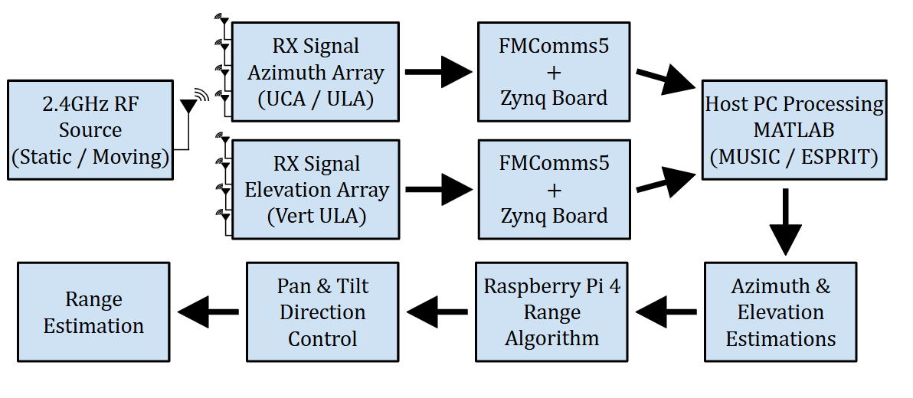
Fig 12. Real-Time Dual-Array Direction-of-Arrival Demo Architecture

The physical implementation directly mirrors the high-level architecture described above. The RF source consists of a USRP-2901 transceiver controlled by a Raspberry Pi 4, configured to transmit a continuous 2.4 GHz tone during testing. This compact transmission module provides a stable, low-profile, and easily repositioned source, allowing controlled static and dynamic movement throughout the test environment. The portability of the source enables repeatable angle verification and real-time tracking demonstrations without requiring large laboratory infrastructure. The architecture of the RF emitter subsystem is shown in Figure 13.
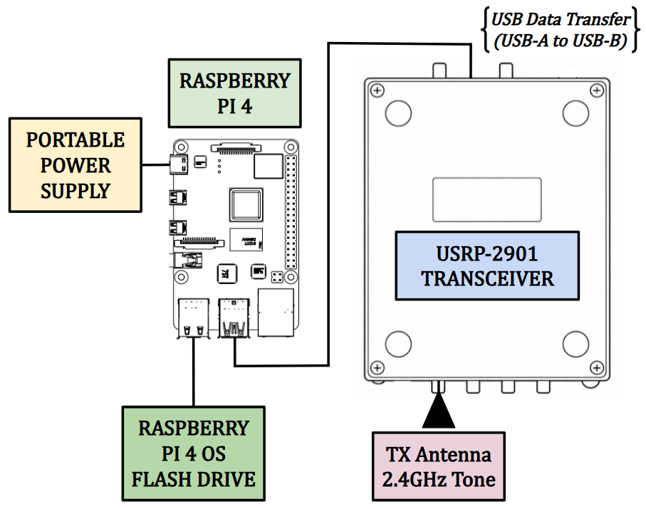
Fig 13. Live Demo Portable RF Source Testbed

RF Receiver Architecture

The most critical part of the hardware setup is the RF receiver system, which is responsible for capturing the emitted signal and computing the direction-of-arrival (DoA) estimation. The receiver architecture consists of three primary sections: the antenna array used to collect the incoming RF signal, the FMComms5/Zynq signal acquisition platform that performs RF downconversion and digitization, and a host PC where the DoA processing algorithms are executed in MATLAB. Two antenna configurations were implemented for testing: a UCA–ULA configuration for azimuth and elevation estimation, as shown in Figure 14, and a dual ULA configuration used for comparison.
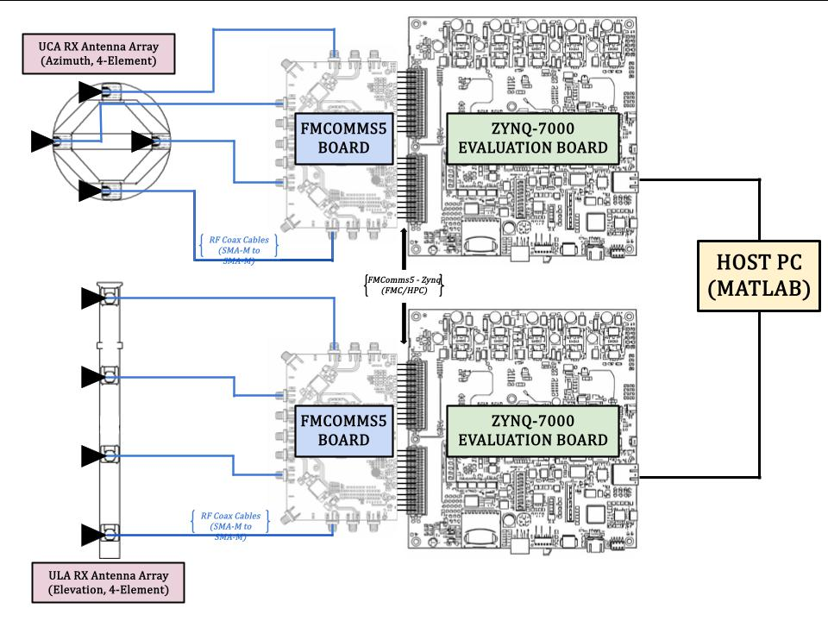
Fig 14. Live Demo RF Receiver Architecture (ULA/UCA)

Mechanical Range Architecture

After the azimuth and elevation estimations have been computed by the receiver system, the resulting directional information is transferred to the mechanical ranging subsystem to complete source localization. This subsystem consists of a Raspberry Pi controller, a pan–tilt servo platform, and a TF-02 LiDAR sensor used for distance measurement. The Raspberry Pi receives the estimated pointing angles from the host PC and commands the pan and tilt servos to orient the sensor toward the estimated direction of the RF source. Once aligned, the TF-02 LiDAR measures the distance to the target, allowing the system to estimate the full position of the emitter. The architecture of the mechanical range finding subsystem is shown in Fig. 15.
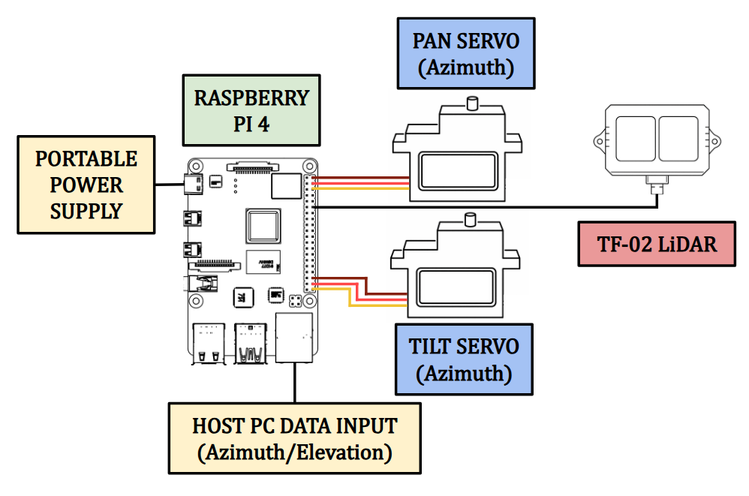
Fig 15. Live Demo Mechanical Range Finding Architecture

Complete Implementation

After completing the individual development of the emitter testbed, RF receiver subsystem, and LiDAR range-finding architecture, the final stage of the project is the integration of these components into a unified localization system. The figure below illustrates the complete system implementation, showing how each subsystem interacts to estimate the azimuth and elevation of the RF source before performing the final range measurement.

Starting with the emitter testbed (Fig. 13), shown in the top left of Fig. 16, a continuous 2.4 GHz waveform is generated by the Raspberry Pi 4 and transmitted through the USRP-2901 software-defined radio. This signal propagates through the surrounding environment and acts as the RF source used for the localization experiments.

Once the emitted signal is captured by the antenna array, in either the ULA/UCA or ULA/ULA configuration, the received RF signals are routed to the FMComms5/Zynq signal acquisition platform, Figure 14 and center of Figure 16. The platform simultaneously samples each antenna channel while preserving the phase relationships between elements, which are required for accurate direction-of-arrival estimation. The digitized data is then processed using the MUSIC algorithm to estimate the azimuth and elevation angles of the incoming signal.

After the azimuth and elevation estimations are completed, the calculated directional information is transferred to the Raspberry Pi 4 to control the pan/tilt servo motors that position the LiDAR sensor. The LiDAR is then aligned with the estimated direction of arrival and performs a range measurement toward the RF source. By combining the angular estimates from the RF receiver with the distance measurement from the LiDAR sensor, the system is able to determine the spatial location of the emitter within the test environment.

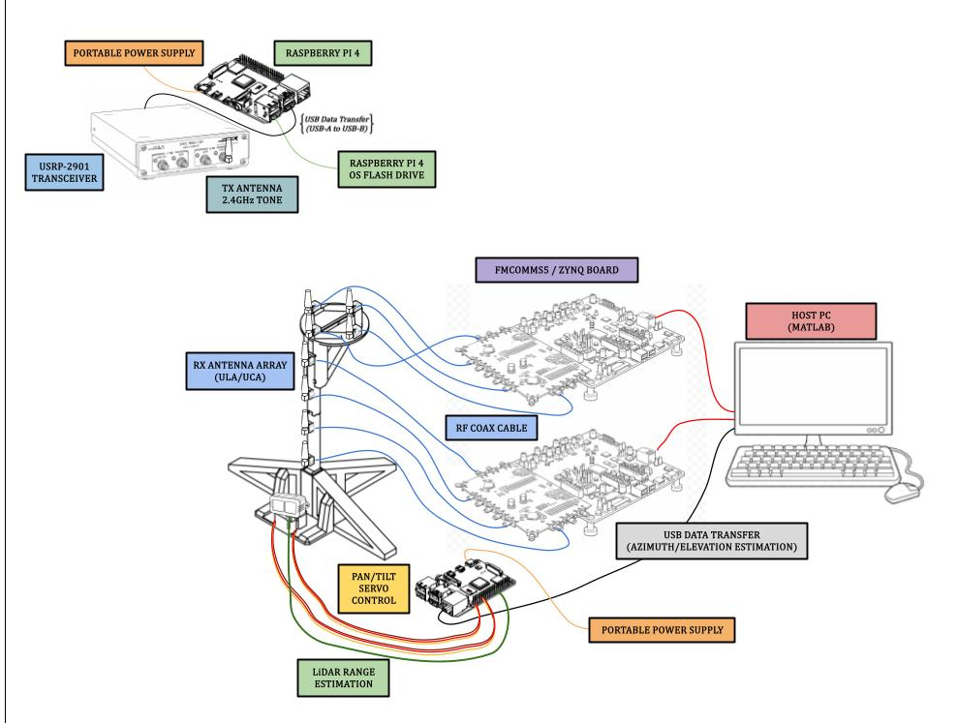
Fig 16. Live Demo Complete Implementation Visualization

Receiver Phase Synchronization
One of the most important factors in any DoA system is the phase synchronization of the receiver system. This system synchronization is achieved using the multi-chip synchronization capability of the FMComms5 boards, which contain dual AD9361 RF transceivers. The configuration, shown in Figure 17, ensures that the local oscillators, sampling clocks, and digital data paths across all receive channels start in a deterministic and phase-aligned state. As shown in the figure below, RF coaxial cables are connected from the TX channels to their respective RX channels during the phase synchronization process. A more detailed description of this procedure can be found in the appendices.
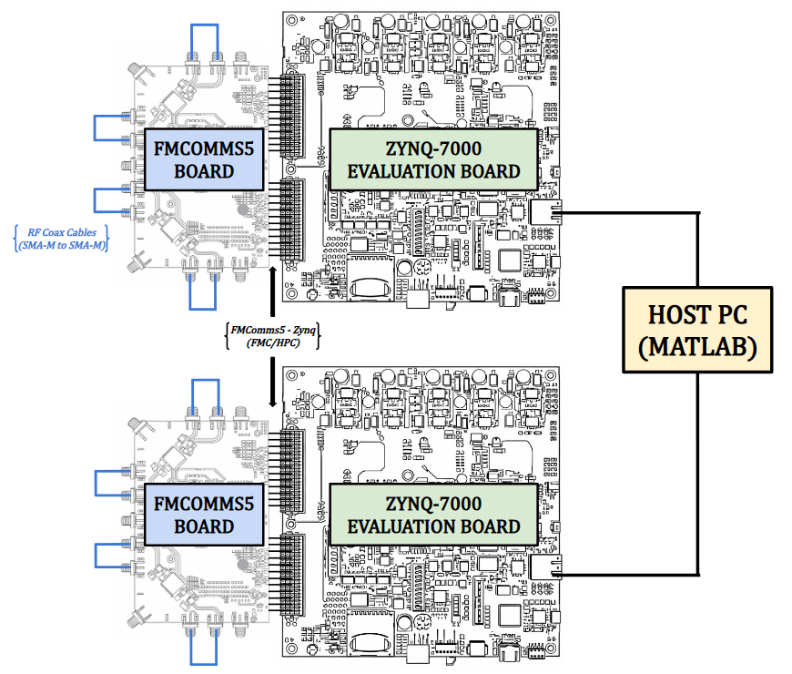
Fig 17. Receiver Phase Synchronization Set-Up

Testing Apparatus
The final phase of the demonstration setup focuses on accurately testing the system and collecting data for performance evaluation. Testing is conducted in two phases. The first phase evaluates the individual antenna array segments using both static and moving RF sources to verify that each array can independently estimate the appropriate angular component. The second phase integrates the arrays into either the ULA/UCA or ULA/ULA configuration, with the LiDAR range finding, to perform full azimuth, elevation, and range DoA testing under both static and moving source conditions. Since the RF source must move in both azimuth and elevation in a semi-controlled manner, a dedicated testing apparatus was developed. This apparatus allows the RF transmitter to move along a pivoting axis, maintaining a constant radial distance from the antenna arrays as it sweeps through different azimuth angles. A pulley-based vertical adjustment system is also incorporated to vary the elevation of the transmitter while maintaining the same horizontal radius. Known angular positions and vertical heights are measured and recorded so that when the transmitter is placed at a static location, the estimated DoA results can be directly compared to the known azimuth and elevation angles for accuracy verification.

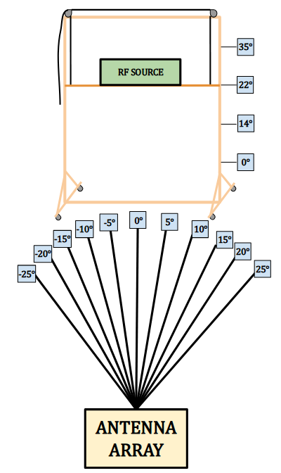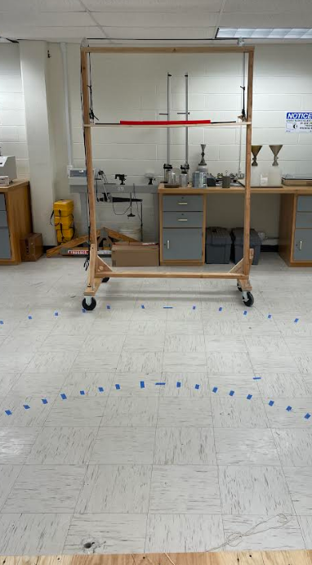
Fig 18. Live Demo Testing Apparatus
Using the apparatus above in Figure 18, the proposed DoA system was experimentally tested to evaluate overall performance. During testing, two primary parameters were varied: the signal processing algorithm and the antenna array configuration. The MUSIC algorithm was evaluated while operating with both the ULA and UCA array configurations. Static testing was first conducted with the RF emitter positioned at known azimuth and elevation angles to establish a baseline for estimation accuracy. After static testing was completed, the same testing procedure was repeated with a moving RF source. During these moving tests, the emitter was only moved in the direction of interest; for example, during azimuth tests the elevation angle remained constant, and during elevation tests the azimuth angle remained fixed.

RESULTS AND OBSERVATIONS
Throughout this section, estimation data collected during live system demonstrations is analyzed to evaluate overall performance. Although both static and moving source data were obtained, the static results are presented in the appendix, while this section focuses on the moving source results. Prior to full system integration, each antenna array geometry was tested individually to verify performance and characterize its estimation capabilities.

UCA Azimuth Testing

The moving source trials evaluate the performance of the UCA for azimuth estimation under real-time indoor conditions. These trials were conducted in a controlled environment to allow consistent tracking of a single RF source while capturing live system data.

As shown in Fig. 20 and Fig. 21, the estimated azimuth follows the overall trend of the measured data in both trials, demonstrating the system’s ability to track a moving source in real time. While the general trajectory is well captured, increased variability is observed in the instantaneous error compared to simulation results. The lower plots present the error on a logarithmic scale along with the running RMSE, which provides a cumulative measure of performance throughout each trial.

In both cases, the instantaneous error exhibits noticeable fluctuations; however, the running RMSE converges and stabilizes over time. The final RMSE values of approximately 11° and 16° indicate consistent, though degraded, performance relative to simulation. This increase in error is expected in real-world conditions due to factors such as noise, multipath propagation, and hardware non-idealities.
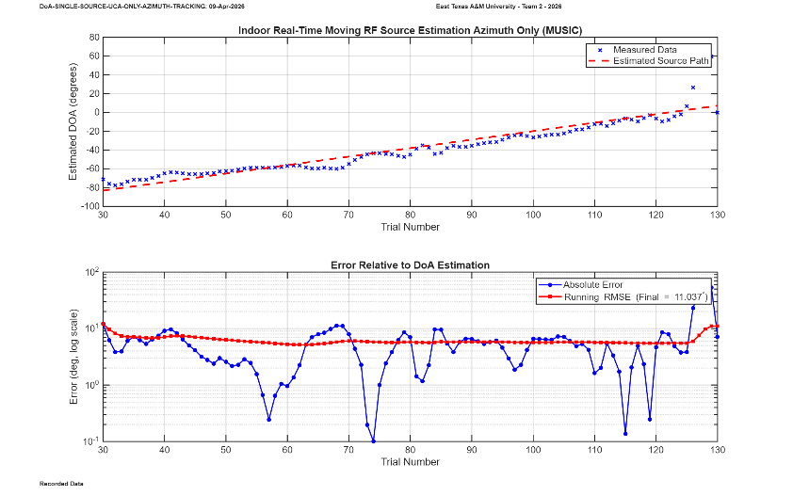
Fig 20. Trial One Real-Time Azimuth Estimation of Single Moving RF Source Using UCA (Log Scale Error); Indoor Environment; Running RMSE = 11°; Elevation: 20°; Azimuth: -80°:10°
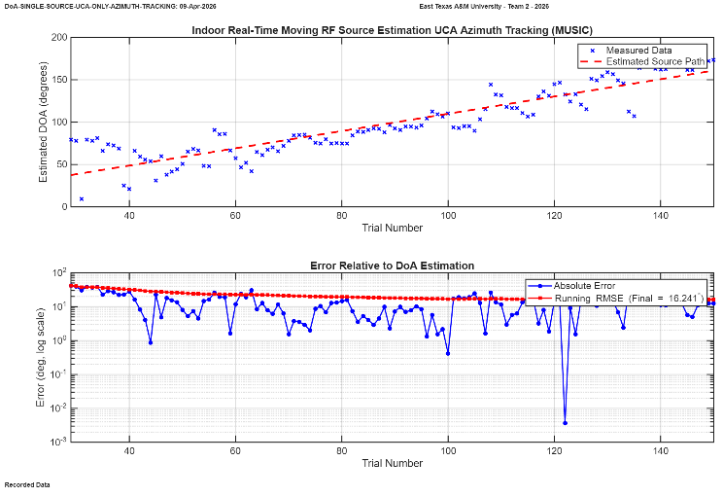
Fig 21. Trial Two Real-Time Azimuth Estimation of Single Moving RF Source Using UCA (Log Scale Error); Indoor Environment; Running RMSE = 16.241°; Elevation: 35°; Azimuth: 35°:160°

ULA Azimuth Testing

The second set of moving source trials evaluate the ULA azimuth estimation, trials were conducted under the same indoor conditions as the UCA experiments to provide a direct performance comparison. These tests evaluate the ability of the linear array to track a moving RF source in real time.

As shown in Fig. 22 and Fig. 23, the estimated azimuth closely follows the measured trajectory in both trials, demonstrating accurate tracking performance. Compared to the UCA results, the ULA exhibits reduced variability in the instantaneous error, particularly during steady-state motion. The lower plots show the error on a logarithmic scale along with the running RMSE, which converges and stabilizes throughout each trial.

The final running RMSE values of approximately 5.9° and 17.9° indicate improved performance in the first trial and comparable performance in the second trial relative to the UCA results. The increased error observed in the second trial is likely due to environmental effects such as multipath and signal fluctuations, which impact system performance during real-time operation.

It should also be noted that the azimuth range in Fig. 23 is represented from 0° to 180°, rather than −90° to 90° as in Fig. 22; however, both representations correspond to the same physical angular space and do not affect the interpretation of the results.
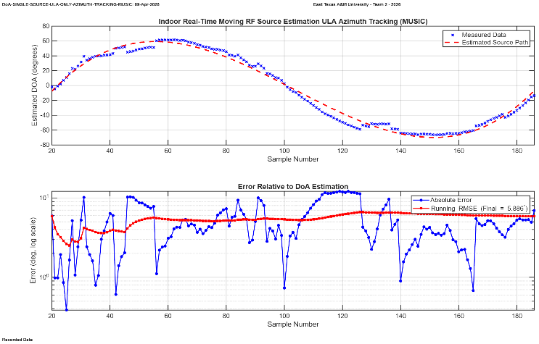
Fig 22. Trial One Real-Time Azimuth Estimation of Single Moving RF Source Using ULA (Log Scale Error); Indoor Environment; Running RMSE = 5.886°; Elevation: 0°; Azimuth: 0°:60°:-70°:0
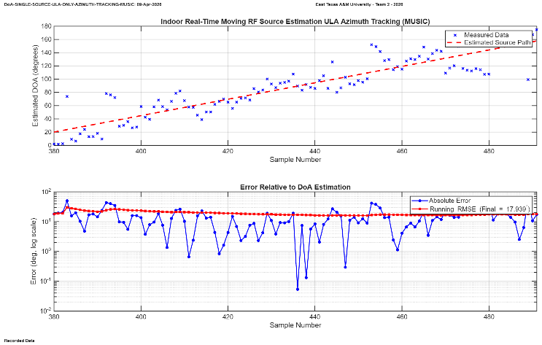
Fig 23. Trial Two Real-Time Azimuth Estimation of Single Moving RF Source Using ULA (Log Scale Error); Indoor Environment; Running RMSE = 17.939°; Elevation: 25°; Azimuth: 20°:160°

ULA Elevation Testing

The final set of individual array tests evaluates the performance of the ULA for elevation estimation. These trials were conducted in the same indoor environment as the previous experiments to ensure consistency and allow direct comparison across array configurations.

As shown in Fig. 24 and Fig. 25, the estimated elevation generally follows the trend of the measured data, demonstrating the system’s ability to track changes in elevation over time. However, compared to the azimuth estimation results, greater variability is observed in the instantaneous error. The lower plots present the error on a logarithmic scale along with the running RMSE, which provides a cumulative measure of performance throughout each trial.

In both trials, the running RMSE converges and stabilizes over time, with final values of approximately 3.9° and 7.7°, respectively. While the first trial demonstrates relatively strong performance, the second trial exhibits increased error and variability, likely due to environmental effects such as multipath, reduced elevation sensitivity, and signal fluctuations. Overall, the ULA provides reliable elevation tracking capability, though with slightly higher variability compared to azimuth estimation.
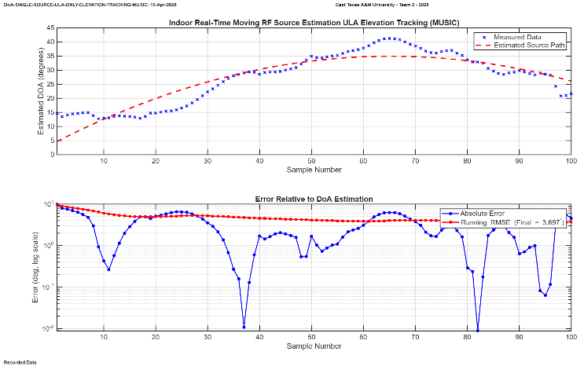
Fig 24. Trial One Real-Time Elevation Estimation of Single Moving RF Source Using ULA (Log Scale Error); Indoor Environment; Running RMSE = 3.697°; Elevation: 5°:40°:25°; Azimuth: 25°
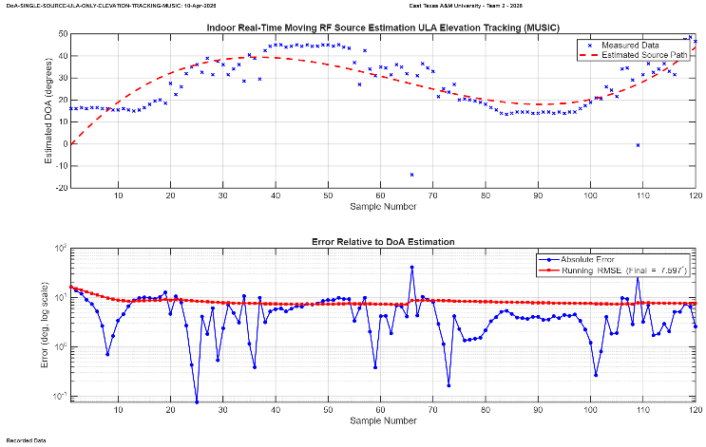
Fig 25. Trial Two Real-Time Elevation Estimation of Single Moving RF Source Using ULA (Log Scale Error); Indoor Environment; Running RMSE = 7.597°; Elevation: 0°:45°:20°:45°; Azimuth: -30°

LiDAR Range Finding
This section has not been written yet

Full Localization Implementation
This section has not been written yet

CONCLUSION
This work presented the design, implementation, and evaluation of a hybrid RF localization system capable of estimating the azimuth, elevation, and range of a single moving RF source in real time. By combining subspace-based Direction-of-Arrival (DoA) estimation algorithms with a dual-array antenna architecture and LiDAR-based range sensing, the system demonstrates a practical approach for full localization of an RF emitter. The proposed architecture separates azimuth and elevation estimation across orthogonal antenna arrays, allowing the two-dimensional DoA estimation problem to be decomposed into two independent one-dimensional estimation problems. This approach reduces computational complexity while maintaining accurate directional estimation within the real-time processing constraints of the system.
Two primary antenna geometries were investigated throughout this work. A uniform circular array (UCA) was used to evaluate azimuth estimation performance, while uniform linear arrays (ULA) were used for elevation estimation and for configurations requiring shift-invariant array structures. The MUSIC algorithm was evaluated through both Monte Carlo simulations and experimental testing to assess its performance under varying signal-to-noise ratios, snapshot counts, and array configurations. Simulation results demonstrated that algorithm performance is strongly influenced by array geometry and signal quality, with the algorithm exhibiting improved stability as SNR and snapshot counts increase. In particular, the results highlighted the threshold behavior commonly observed in subspace-based methods when operating near low SNR conditions.
Experimental validation further confirmed the effectiveness of the proposed system architecture. Testing with both static and moving RF sources demonstrated that the hybrid antenna configuration is capable of producing stable DoA estimates in realistic indoor environments where multipath reflections are present. The system successfully tracked the motion of an RF emitter while maintaining consistent azimuth and elevation estimates across repeated trials. By integrating the DoA estimation output with a LiDAR-based range measurement subsystem, the platform demonstrated the ability to perform full localization of the RF source in real time.
Future work may focus on improving system robustness in challenging RF environments by increasing the number of antenna elements, investigating additional array geometries, and incorporating advanced signal processing techniques for multipath mitigation. Additional development could also include extending the system to support simultaneous localization of multiple RF sources and implementing real-time optimization of algorithm parameters to improve performance under varying signal conditions. These improvements would further expand the applicability of the proposed system to real-world RF sensing applications such as spectrum monitoring, emitter tracking, and electronic warfare systems.

ACKNOWLEDGEMENTS
We would like to thank the Air Force Research Laboratory (AFRL) and the Wright Brothers Institute (WBI) for hosting and supporting the AFRL SDR University Challenge, and for providing the competition structure, technical feedback opportunities, and an evaluation venue for the project demonstration. We would also acknowledge East Texas A&M University (ETAMU) for institutional support and resources that enabled development and testing of the prototype system. Appreciation is extended to the project’s faculty advisor(s), technical mentors, and laboratory staff for guidance on RF hardware integration, calibration practices, and experimental methodology. Additional thanks are given to the challenge sponsors and tool providers who supported the program and student teams through hardware and software resources, including organizations such as MathWorks and National Instruments, as applicable to the competition year.

